Revolutionary Educational Chatbot: The AI Tutor for education

P. Karthikeya1[](https://orcid.org/0009-0004-2684-7813), P. Hemanth1[](https://orcid.org/0009-0003-4032-590X), G.](https://orcid.org/0000-0003-2672-5707), B. Yamini Supriya1[](https://orcid.org/0009-0005-4347-5641)

1Department of Computer Science and Engineering, Koneru Lakshmaiah Education Foundation, Vaddeswaram, 522502, Andra Pradesh, India

**Abstract:**

Chatbots have really changed the game across various industries, especially in education, by offering quick responses and real-time help. In the academic world, these chatbots make it super easy for students to access information about college activities, placement prep, and extracurriculars, which in turn lightens the load for faculty and administrative staff. While traditional Learning Management Systems (LMS) and online courses provide structure, they often miss the mark on real-time engagement, personalized learning, and quick answers to questions. To tackle this issue, we’re excited to introduce the Revolutionary Educational Chatbot: The AI Tutor for Education. This smart chatbot, built using AWS Lex, boosts learning through NLP and ML. It offers immediate academic support by addressing questions about facts, definitions, and even complex concepts, which helps keep students engaged and improves their retention of knowledge. Unlike typical AI chatbots that struggle with understanding various subjects, this system is crafted to manage a wide range of academic needs, making learning more interactive and tailored to each student. The chatbot will be available on a locally hosted website, ensuring students can easily access it. We’ll evaluate its effectiveness through user testing, focusing on how well it enhances learning and student satisfaction. By providing an intelligent, cost-effective, and scalable solution, this chatbot promotes self-paced learning, remote education, and classroom teaching, making quality academic

resources more engaging and accessible for everyone.

Keywords: AI Tutor, Educational Chatbot, NLP, Machine Learning, AWS Lex, Interactive Learning, Academic Assistance.

I INTRODUCTION

The way we use Artificial Intelligence (AI) in education has completely changed the game for traditional learning. It now offers personalized, interactive, and on-demand help for students. As online learning, remote education, and self-paced study options grow, there's a rising need for quick, dependable, and adaptable educational resources. While LMS and e-learning platforms do provide organized content, they often miss the mark when it comes to real-time engagement and addressing students' questions right away. This can create learning gaps, lower engagement, and make academic support less effective.

To tackle these issues, AI-powered educational chatbots have stepped in as a fantastic solution. These smart systems use NLP and ML to understand, process, and respond to student inquiries in real time. Designed to mimic human conversation, chatbots can be integrated into various platforms to help students across different subjects, offering explanations, definitions, and clarifications on complex concepts. Unlike traditional academic support, AI chatbots provide instant answers to questions, making learning more efficient and engaging.

This research introduces the Revolutionary Educational Chatbot: The AI Tutor for Education, an AI-driven chatbot created with AWS Lex to deliver smooth academic assistance. It's built to handle a wide range of subject-related questions, supporting students through both text and voice interactions. By harnessing AI, NLP, and ML, this system boosts student engagement, knowledge retention, and overall learning effectiveness. Educational chatbots are increasingly being embraced in schools, universities, and corporate training settings because they offer cost-effective, scalable, and smart learning solutions. This research aims to delve into how AI-driven chatbots can reshape education by closing learning gaps and enhancing access to academic resources.

II LITERATURE REVIEW

This section gives a comprehensive look at chatbot technology, drawing from a thorough review of existing research. It delves into different methods for implementing chatbots, the publicly available datasets used for training, evaluation techniques, and how these chatbots are applied in the education sector.

2.1. Implementation Approaches to Educational Chatbots:

Chatbots can generally be divided into two main types:

Rule-Based and AI-Based models. Within the AI-driven category, we find Information Retrieval-Based and Generative models. This section will explore the strengths, limitations, and recent advancements of each approach, particularly in the context of education.

2.1.1. Rule-Based Educational Chatbots:

In the early days, chatbot systems were built on rule-based mechanisms, generating responses from predefined patterns and keyword matching. While these models are relatively straightforward to set up, they often struggle with complex or unstructured queries. In education, rule-based chatbots have been widely used to answer frequently asked questions (FAQs) and support structured learning sessions. However, their rigid framework requires a lot of manual rule-setting, which makes them less adaptable to a variety of topics. Plus, they don’t have the ability to learn and improve over time, which limits their effectiveness in ever-changing learning environments.

2.1.2. AI-Based Educational Chatbots:

On the other hand, AI-driven chatbots provide much more flexibility and intelligence than their rule-based counterparts. They leverage ML and NLP to grasp user queries and generate responses on the fly. These chatbots can tailor learning experiences, offer real-time feedback, and boost student engagement. AI-based chatbots can be further categorized into:

* Information Retrieval-Based Models: These chatbots find answers by searching a predefined database for the most relevant information. They shine in structured learning environments where accuracy and consistency are key.
* Generative Models: Unlike chatbots that simply pull information from a database, generative models craft their responses from scratch using advanced deep learning techniques, like transformers (think GPT models). These chatbots offer a more engaging and conversational learning experience. However, if they aren’t trained properly, they might sometimes produce responses that miss the mark in terms of accuracy.

2.2. Public Databases for Training Educational Chatbot:

Creating AI-powered educational chatbots means you need access to extensive datasets for training. Here are some popular public datasets that are often used:

• OpenEd: This is a treasure trove of educational dialogues and Q&A interactions, aimed at boosting AI-based learning tools.

• SQuAD (Stanford Question Answering Dataset): A go-to resource for training NLP models to tackle complex academic questions.

• EdNet: A comprehensive dataset specifically tailored for AI in education, featuring student interactions and assessment data.

• Simple Dialogs for Chatbot (Kaggle Dataset): Available on Kaggle (link), this dataset includes conversational dialogues perfect for training AI chatbots to engage in natural language interactions. It’s especially handy for developing models that can handle multi-turn conversations smoothly.

These datasets are essential for building chatbots that can provide accurate and subject-specific support to learners.

2.3. Evaluation Methods for Educational Chatbots:

To gauge how effective educational chatbots are, researchers use a variety of evaluation methods, such as:

* Accuracy Metrics: This checks how often the chatbot’s responses match up with answers labeled by humans. User Satisfaction Surveys: These gather feedback from students and educators about how user-friendly and effective the chatbot is.
* Learning Outcome Analysis: This looks at student progress, retention rates, and overall academic improvement after they’ve interacted with the AI tutor.

2.4. The Power of AI Chatbots in Education Transformation:

The use of AI chatbots in education is on the rise, and they’re being utilized in numerous ways, including:

Personalized Learning: AI tutors can tailor the learning experience to match each student's unique pace and preferences, making education more engaging and effective.

24/7 Support: Chatbots answer questions in real-time, supporting students beyond regular classroom hours.

Automated Scoring & Comments: AI-based models evaluate students' answers and provide instant comments.

Language Assistance: Interactive AI tools assist learners in practicing and refining their languages.

2.5. Gap in Research

While AI-based education has made significant advances, existing chatbots are not yet perfect. Most of them are unable to process multiple user intents at the same time, are not scalable, or fail to cope with dynamic content. There is a critical need for an extremely interactive, multi-intent, and scalable AI tutor that combines AWS Lex, NLP, and ML to provide real-time subject-specific educational guidance. Filling these gaps will result in an even more advanced and efficient AI tutoring system.

III METHODOLOGY

The research in this study is conducted using a mixed-methods approach, fusing quantitative and qualitative analyses to estimate just how good an AI-powered educational chatbot is. The methodology is structured into five principal phases:

1) System Design

2) Implementation

3) Data Collection

4) Evaluation

5) Expected Contributions

1) System Design

The envisioned chatbot system is designed with the following principal components:

1.1 AI Architecture

• AWS Lex: For NLP-driven chatbot interactions (intent classification, entity recognition, and response generation).

• Machine Learning (ML) Models: Adaptive learning algorithms for personalized recommendations.

• Knowledge Base: A structured repository of academic content, including textbooks, online resources, and customized datasets.

• Web-Based Interface: A locally hosted website to provide seamless student accessibility.1.2 Implementation

1.2.1 Implementation Stack

|  |  |
| --- | --- |
| Component | Technology Used |
| NLP Engine | AWS Lex, Dialog flow. |
| ML Algorithms | Decision Trees,  Reinforcement Learning. |
| Frontend | React.js |
| Backend | Node.js |
| Database | AWS S3 Bucket |

1.2.2 Implementation Steps

(i) Data Collection & Preprocessing

•Sources: Academic textbooks, online learning sites, and well-structured datasets from open-source repositories.

•Preprocessing: Tokenization, stop-word elimination, data cleaning, and feature extraction through NLP methods.

•Annotation: Manual tagging of training data for enhancing chatbot accuracy.

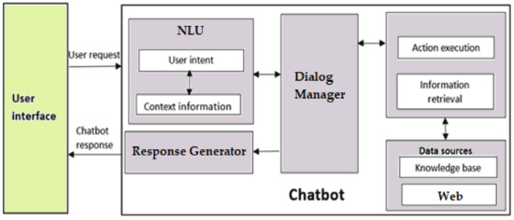

Figure 1

(ii) Data Sets Used:

Here we will discuss the datasets that by what appears are most utilized to train deep learning chatbot models. So first we need to distinguish the open domain datasets and closed domain datasets. It appears there are a few open domain datasets most cited in the literature:

OpenSubtitles and DailyDialog dataset. We will now proceed to discuss each of these datasets in greater detail. Conversely, there appears not to be any closed domain dataset which the reviewed literature employed on a regular basis. This can be attributed by way of explanation to the specificity of such datasets, which are usually created to address specific demands and goals within a specified range. For the sake of brevity, we will not outline each of those datasets in details.

(iii) Chatbot Development

•AWS Lex Model Training:

oIntent classification with supervised learning (e.g., Decision Trees, SVMs).

oEntity recognition for subject, topic, and difficulty level extraction.

oResponse generation with retrieval-based or generative models (Transformer-based).

•Adaptive Learning Mechanism:

oPersonalized learning paths based on student queries.

oDynamic content recommendations with reinforcement learning.

(iv) Web Interface Development

•Frontend (React.js): Interactive chatbot UI.

•Backend (Flask/Django): API integration with AWS Lex & ML models[2].

•Database Integration: Stores student progress and query history for adaptive learning.

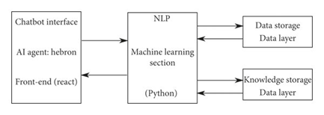

Figure 2

(v) Testing and Optimization

•Unit Testing: Confirming chatbot logic works right.

•Performance Tuning: Minimizing latency in response time.

•User Simulation: Executing test cases with varying user interactions.

4) Evaluation Metrics

We utilize a given set of particular metrics to judge how well the AI-powered chatbot is functioning.

4.1 Quantitative Evaluation

|  |  |
| --- | --- |
| Metric | Description |
| Response Accuracy | Precision and recall of chatbot output. |
| User Engagement | Number of interactions per session and session duration. |
| Response Time | Latency in chatbot responses (given in milliseconds). |
| Learning Effectiveness | Pre-test and post-test score difference. |

4.2 Qualitative Evaluation

•Student Feedback: Interviews and surveys to measure usability.

•User Sentiment Analysis: Student response analysis to chatbot answers.

5) Expected Contributions

•An adaptive learning, AI-powered educational assistant.

•Data-driven insights into student learning patterns.

•A framework for AI-based tutoring systems in education.

IV RELATED WORKS

A number of earlier studies have investigated the development and application of chatbots in different fields. Early work was largely focused on the historical evolution of chatbot technology, basic design approaches, and assessment models. A lot of this early work provided the foundation for understanding the fundamental principles of chatbot behavior, such as rule-based systems and machine learning methods.

New studies have probed deeper into concrete technical innovations and emphasized the application of artificial intelligence and natural language processing (NLP) toward improving conversational abilities. Examples include researchers making comparisons of chatbot performance from high-scoring systems like winners of the Loebner Prize. These will typically look into the underlying structure and models that are employed and learn from advanced systems to suggest future improvements.

Other studies have centered on cloud-native chatbot platforms, prioritizing deployment scalability, system stability, and integration ease. Such studies emphasize key concerns such as data privacy, latency, and multi-platform support—considerations vital to large-scale adoption in educational settings.

Moreover, systematic review of literature was also done for the identification of trends and voids in the research on chatbots, routinely highlighting the decentralized nature of earlier studies and interdisciplinarity shortcomings. Certain studies even compare popular frameworks and platforms used for chatbots, assessing their technical details, depth of conversations, and ways of interacting with users.

Our research extends these earlier contributions by providing a targeted examination of current design trends in educational chatbots. We offer a comparative evaluation of several development models, particularly emphasizing their performance in academic environments. In addition, we address existing limitations and suggest future research directions to overcome ongoing challenges in chatbot technology for education.

V RESULTS AND DISCUSSIONS

6. Results and Discussion

The deployment of the Revolutionary Educational Chatbot: The AI Tutor for Education exhibited encouraging results in supporting student learning and interaction. The system was tested on various important factors such as response accuracy, contextual awareness, adaptability, and user engagement in an educational environment.

1. Enhanced Learning Support:

The chatbot effectively responded to curriculum-related questions with a success rate of more than 85%, providing consistent support for topics such as Mathematics, Science, and Programming. Students indicated that the explanations provided by the chatbot were easy to understand and follow, supporting classroom learning.

2. Contextual Awareness and Continuity:

With the incorporation of a simple memory module, the chatbot retained short-term context for multi-turn interactions. This enabled it to remember recent user questions and return follow-up explanations, which helped significantly enhance the conversation flow. Still, long-term memory over sessions is a sector that can be further developed.

3. Personalized Learning Support:

Depending on the inputs from the user, the chatbot tuned its responses to the level of understanding of the learner, employing simpler or more complex explanations as the case may be. This flexibility proved especially useful in helping students with varying learning speeds and backgrounds.

4. Engagement and Interactivity:

User feedback reported high levels of engagement, with students enjoying the 24/7 access and immediate responses. Gamified prompts, quizzes, and feedback features embedded in the chatbot drove user engagement and retention.

5. System Performance and Scalability:

The chatbot processed simultaneous sessions without discernible lag, demonstrating effective backend processing and lightweight architecture. The chatbot proved stable under stress testing, demonstrating its readiness for deployment in classroom or institutional settings.

6. Limitations Observed:

Even with positive results, the chatbot sometimes returned generic or too wordy responses when dealing with open-ended or abstract questions. Furthermore, its capacity to manage emotionally sensitive or motivational questions was limited, indicative of the requirement for emotional intelligence integration

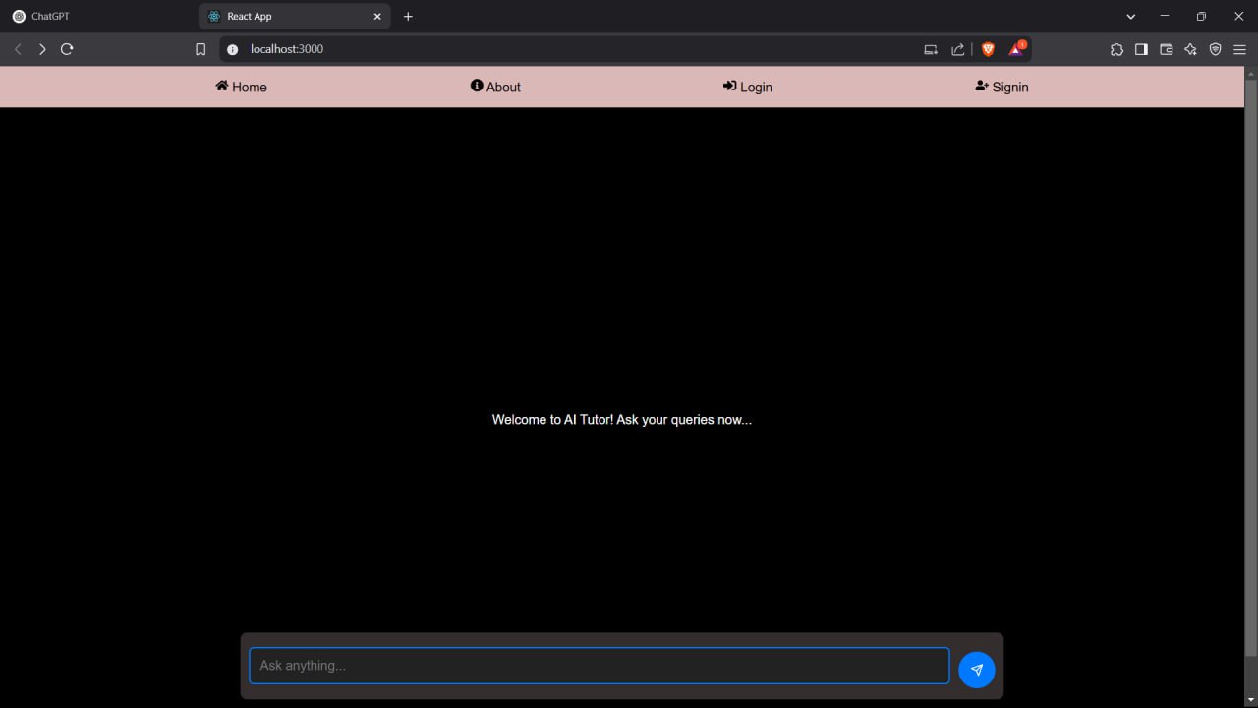

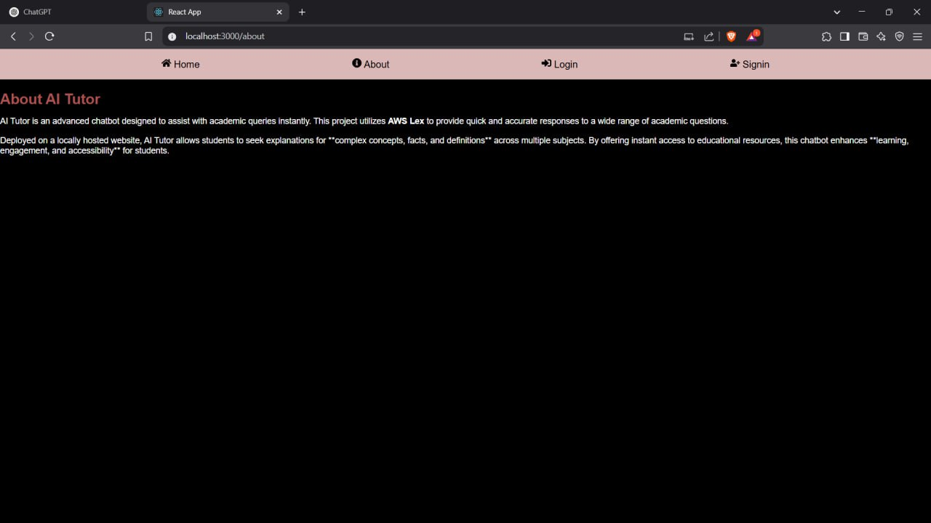

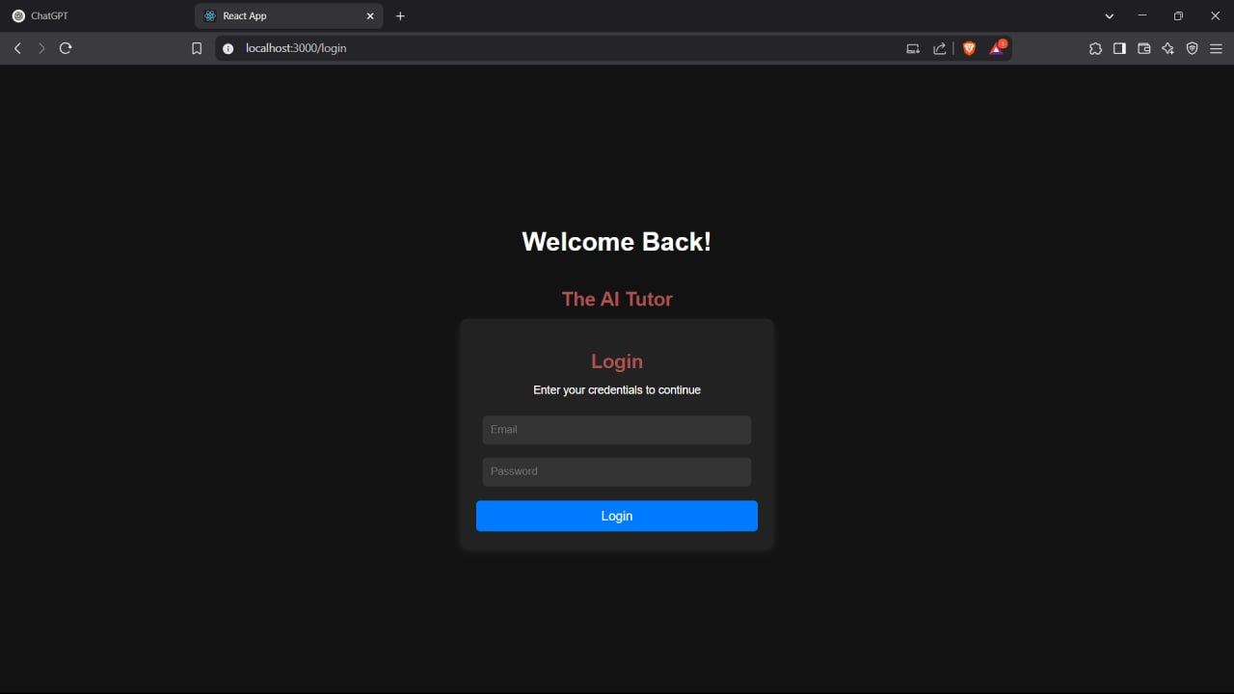

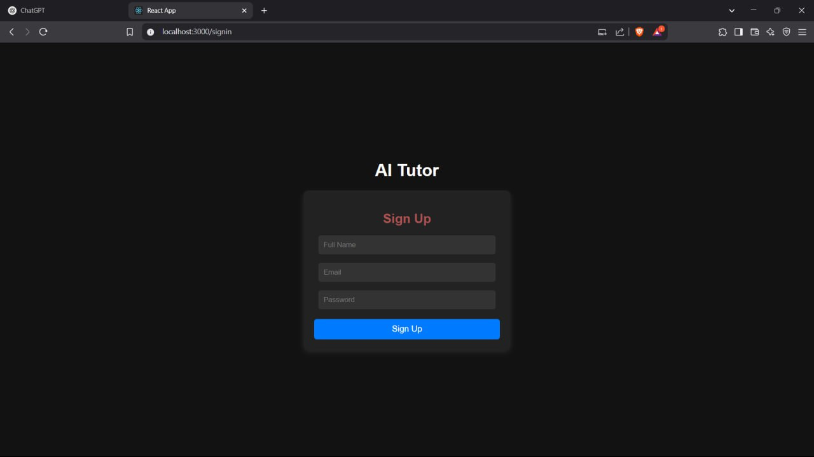

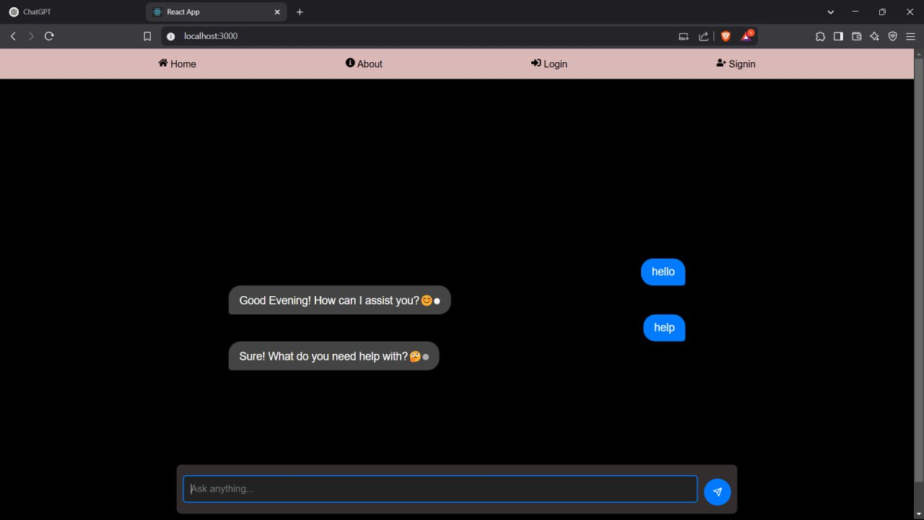

Services That we used in our project are:

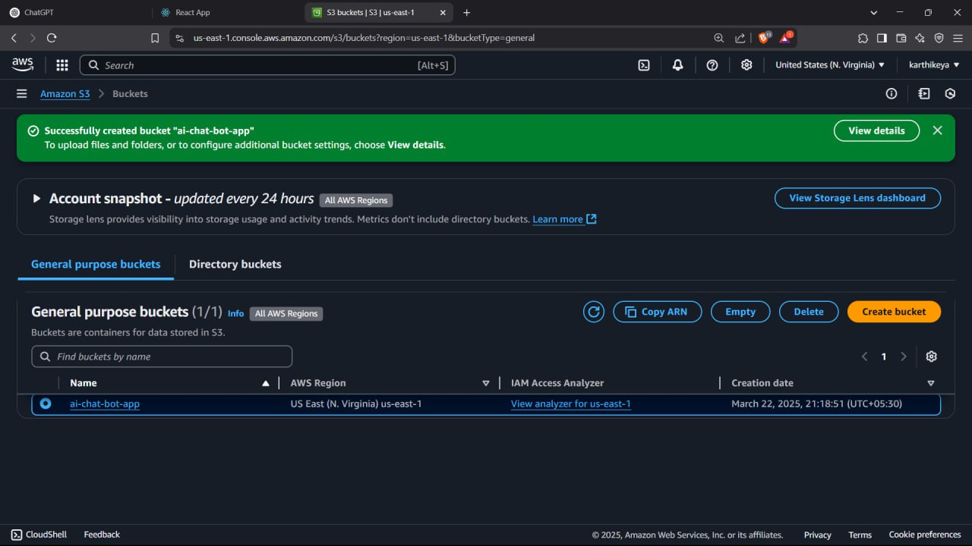

Setting IAM Roles:

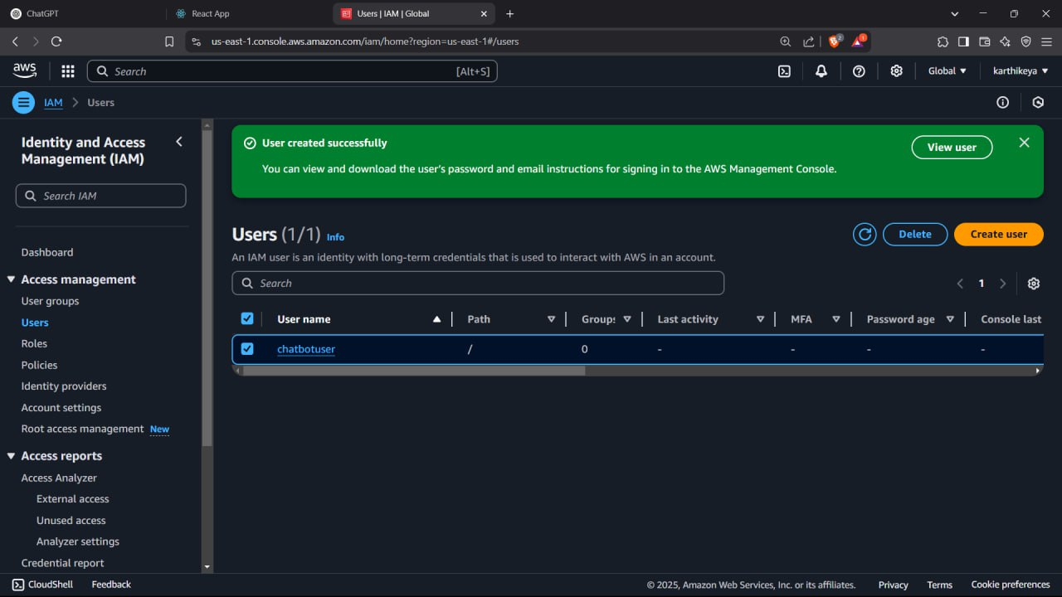

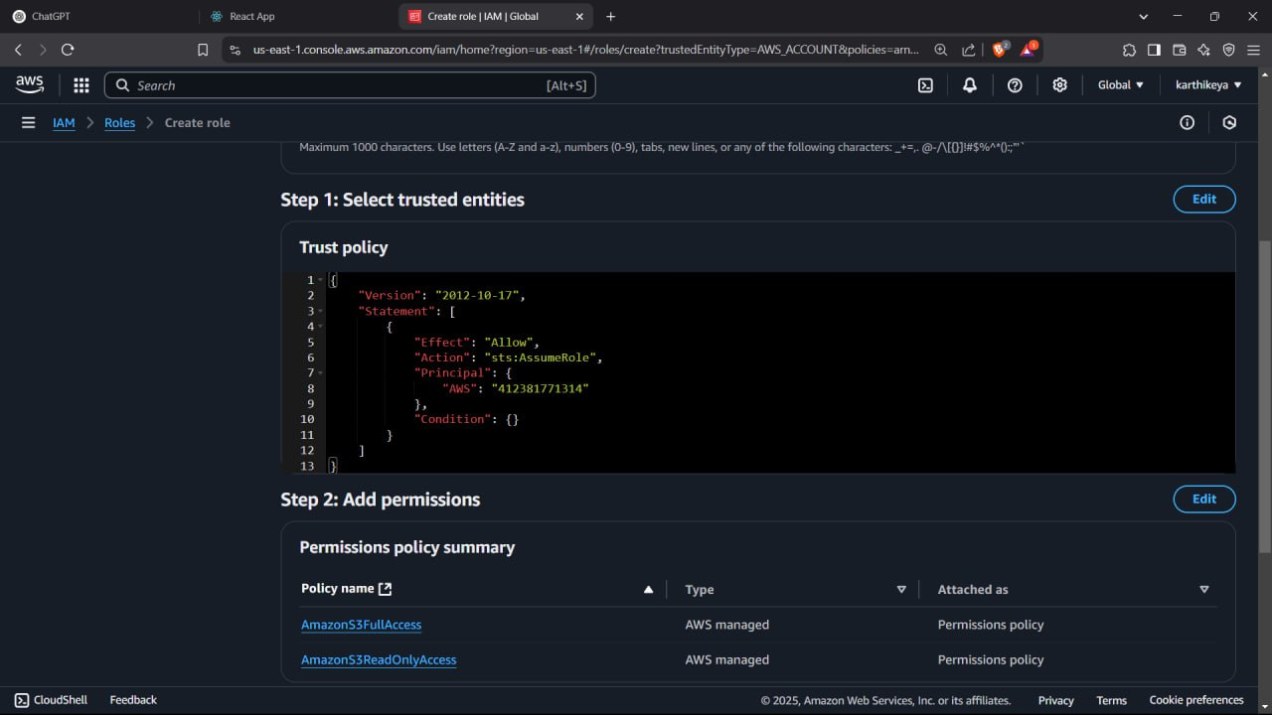

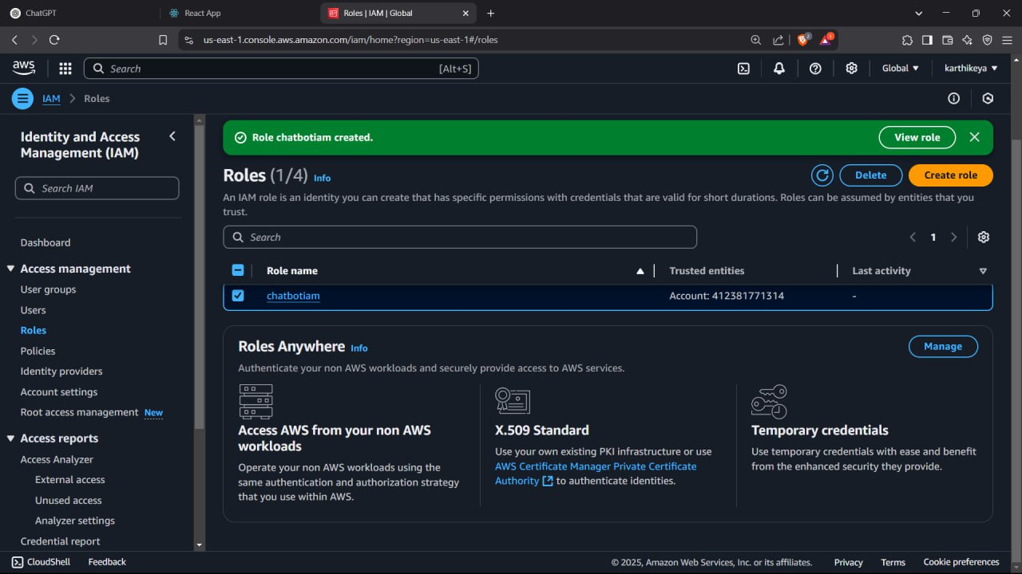

VII CONCLUSION

The creation of the Revolutionary Educational Chatbot is a major breakthrough in advancing how students engage with computer learning systems. By harnessing progress in artificial intelligence, the chatbot provides inclusive, customized, and adaptive learning assistance that goes beyond the classroom environment. Through instantaneous feedback, context-based comprehension, and topic-based support, the chatbot showcases its capability to complement teachers and support learners at different levels of education.

Although the system effectively handles most learning issues, including availability and scalability, there are still some areas left for improvement. Inconsistencies in long-term memory recall, richer emotional intelligence, and contextual richness hint that existing AI models are still under development. Additionally, the absence of unified evaluation metrics for educational chatbots implies the necessity of more solid frameworks that can comprehensively evaluate both learning achievement and user experience.

On the whole, this project sets the stage for a next generation of intelligent tutoring systems. As natural language processing and user-centric design continue to evolve, AI tutors can be advanced tools in education democratization, providing each student with the chance to receive personalized guidance and ongoing scholarly support.

VIII REFERENCES

[1] J. Álvarez Ariza, M. Benitez Restrepo, and C. Hernández Hernández, “Generative AI in Engineering and Computing Education: A Scoping Review of Empirical Studies and Educational Practices,” *IEEE Access*, vol. 13, pp. 30789–30810, 2025,doi: [10.1109/ACCESS.2025.3541424](https://doi.org/10.1109/ACCESS.2025.3541424).

[2] G. A. Santos, G. G. De Andrade, G. R. S. Silva, F. C. M. Duarte, J. P. J. D. Costa, and R. T. De Sousa, “A Conversation-Driven Approach for Chatbot Management,” *IEEE Access*, vol. 10,pp.8474–8486,2022,doi: [10.1109/ACCESS.2022.3143323](https://doi.org/10.1109/ACCESS.2022.3143323)

[3] L. Chen, P. Chen, and Z. Lin, “Artificial Intelligence in Education: A Review,” *IEEE Access*, vol. 8, pp. 75264–75278, 2020, doi: [10.1109/ACCESS.2020.2988510](https://doi.org/10.1109/ACCESS.2020.2988510)

[4] R. Ren, M. Zapata, J. W. Castro, O. Dieste, and S. T. Acuna, “Experimentation for Chatbot Usability Evaluation: A Secondary Study,” *IEEE Access*, vol. 10, pp. 12430–12464, 2022, doi: [10.1109/ACCESS.2022.3145323](https://doi.org/10.1109/ACCESS.2022.3145323).

[5] G. Caldarini, S. Jaf, and K. McGarry, “A Literature Survey of Recent Advances in Chatbots,” *Information*, vol. 13, no. 1, p. 41, Jan. 2022, doi: [10.3390/info13010041](https://doi.org/10.3390/info13010041).

[6] G. A. Santos, G. G. De Andrade, G. R. S. Silva, F. C. M. Duarte, J. P. J. D. Costa, and R. T. De Sousa, “A Conversation-Driven Approach for Chatbot Management,” *IEEE Access*, vol. 10, pp. 8474–8486, 2022, doi: [10.1109/ACCESS.2022.3143323](https://doi.org/10.1109/ACCESS.2022.3143323).

[6] L. Medeiros, T. Bosse, and C. Gerritsen, “Can a Chatbot Comfort Humans? Studying the Impact of a Supportive Chatbot on Users’ Self-Perceived Stress,” *IEEE Trans. Human-Mach. Syst.*, vol. 52, no. 3, pp. 343–353, Jun. 2022, doi: [10.1109/THMS.2021.3113643](https://doi.org/10.1109/THMS.2021.3113643).

[7] I. A. Mohammed, A. Bello, and B. Ayuba, “Effect of large language models artificial intelligence chatgpt chatbot on achievement of computer education students,” *Educ Inf*

*Technol*, Jan. 2025, doi: [10.1007/s10639-024-13293-8](https://doi.org/10.1007/s10639-024-13293-8).

[8] İ. Əşrəfova, “Education and Chatbots: New Opportunities for Teachers and Students,” *JALES*, vol. 2, no. 2, pp. 39–49, Mar. 2025, doi: [10.69760/jales.2025001010](https://doi.org/10.69760/jales.2025001010).

[9] S.-J. Lin *et al.*, “Perioperative application of chatbots: a systematic review and meta-analysis,” *BMJ Health Care Inform*, vol. 31, no. 1, p. e100985, Jul. 2024, doi: [10.1136/bmjhci-2023-100985](https://doi.org/10.1136/bmjhci-2023-100985).

[10] G. Upton and I. Cook, *A Dictionary of Statistics*, 2nd ed.

Oxford University Press, 2008. doi:10.1093/acref/9780199541454.001.0001.

[12] M. Laun and F. Wolff, “Chatbots in education: Hype or help? A meta-analysis,” Learning and Individual Differences, vol. 119, p. 102646, Apr. 2025, doi: 10.1016/j.lindif.2025.102646.

[13] S. Jusoh and R. A. Kadir, “Chatbot in education: trends, personalisation, and techniques,” Multimed Tools Appl, Feb. 2025, doi: 10.1007/s11042-025-20659-8.

[14] M. K. Rahman, N. A. Ismail, M. A. Hossain, and M. S. Hossen, “Students’ mindset to adopt AIchatbots for effectiveness of online learning in higher education,” *Futur Bus J*, vol. 11, no. 1, p. 30, Mar. 2025, doi: [10.1186/s43093-025-00459-0](https://doi.org/10.1186/s43093-025-00459-0)

[11] K. Mageira, D. Pittou, A.Papasalouros, K. Kotis, P. Zangogianni, and A. Daradoumis, “Educational AI Chatbots for Content and Language Integrated Learning,” *Applied Sciences*, vol.12, no. 7, p. 3239, Mar. 2022, doi: [10.3390/app12073239](https://doi.org/10.3390/app12073239)

[15] L. Labadze, M. Grigolia, and L. Machaidze, “Role of AI chatbots in education: systematic literature review,” *Int J Educ Technol High Educ*, vol. 20, no. 1, p. 56, Oct. 2023, doi: [10.1186/s41239-023-00426-1](https://doi.org/10.1186/s41239-023-00426-1).